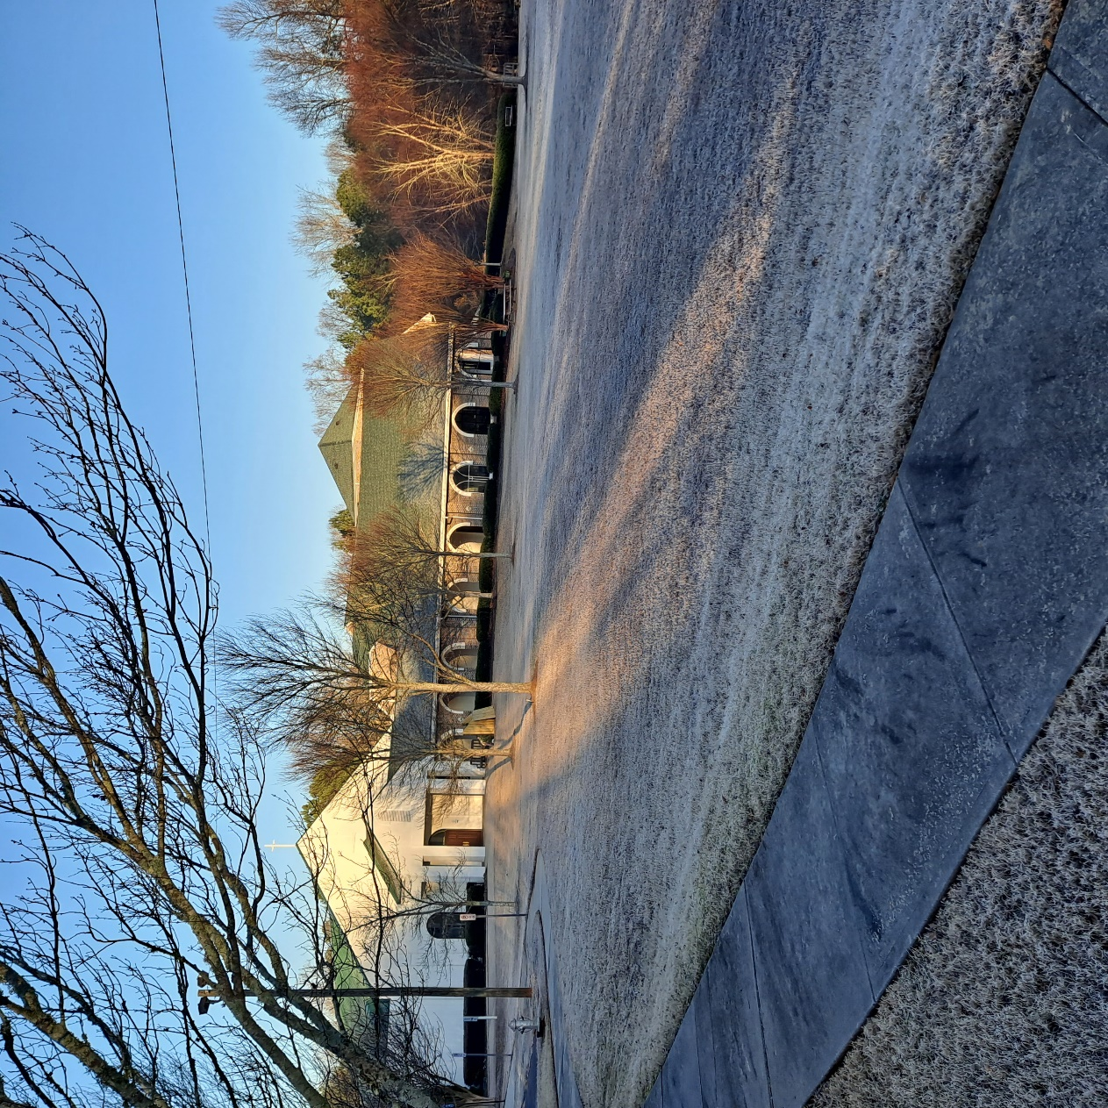 2023 Annual Report

St. Aidan’s Episcopal Church

“To Know Jesus Christ and Make Him Known”

13560 Cogburn Road

Milton, Ga 30004

Phone: 770.521.0207

[Office@staidans.org](mailto:Office@staidans.org)

[www.staidans.org](http://www.staidans.org)

**Table of Contents**

**Leadership 5**

**Introduction 6**

**Membership Journal 2022 6**

**Clergy and Warden Report 7-10**

Rector’s Report for 2022 7-8

Senior Warden’s Report 9-10

**Community Care 11-13**

Pastoral Care 11

Prayer Warriors 11

Memorial Garden 11-12

Daughters of the King 12-13

**Outreach 14-17**

Backpacks of Love 14-15

Rise Against Hunger 16

Episcopal Relief and Development 16

Prayer Shawl 16-17

Blood Drive 17

North Fulton Community Charities 17

Operation Christmas Child 17

**Worship** **18-21**

Vergers 18

Lectors 18

Evening Prayer 19

Memorials for Pets 19-20

Altar Guild 20

Flower Guild 20

Ushers 21

**Ministry of Music 22-24**

**Family Ministries 25-26**

Christian Formation 25

Acolytes 25

New Members 26

**Building and Grounds 27-33**

**Administration** 34-36

Parish Office 34

Communications 34

Finance Committee 35

Episcopal Endowment 35

Stewardship 35-36

**Parish Life 37-38**

Fellowship and Events 37

Men’s Breakfast Ministry 37

Retired Men 37

Women’s Fellowship/ Center Stage Bookclub 38

**Scouting 39**

**St. Aidan’s Preschool 40-41**

**2023 Treasurer Report**  **42**

**Financial Documents Insert**

**Leadership**

|  |  |
| --- | --- |
| **Clergy** |  |
| The Rev. W. Reginald Simmons  The Rev. Joshua Hilton | Rector  Curate, Director of Family Ministries and Pastoral Care |
| Heather Okuda  **Staff** | Director of Communications |
| Anita Hilbun | Parish Administrator (acting) |
|  |  |
|  |  |
| Charles Higgs | Director of Music Ministries |
| Julie Aleksandrowitz | Director of Preschool & MMO |
| **Vestry** |  |
| **\*Vestry members and term ending year\*** |  |
| Curtis Mills, Senior Warden | 2025 |
| Steve Burns, Jr Warden | 2023 |
| Foster FitzHugh, Asst. Jr Warden  Amanda Cantelmo | 2024  2023 |
| Wade Hembree | 2023 |
| Corinne Hofstetter | 2023 |
| Missy Lehigh | 2024 |
| Sam Locklear  Kim Hottenstein  Barry Mansell  Karen Vernon | 2024  2025  2025  2025 |

**Delegates to the 2023 Diocesan Council Alternates to the Delegates**

The Rev. W. Reginald Simmons Carol Phillips

Thomas Horner Anita Hilbun

Suzy Heald Joanne Goione

Thomas Reynolds, Lay Worship Leader Debbie Parkinson

Cathy Biondi

Hazel Gerber

**Introduction**

**“The Holy Spirit is present whenever believers gather together”- Matthew 18:20**

As your temporary Parish Adminstrator and fellow member of our wonderful church, it was an interesting journey to complete the St. Aidan’s 2023 Annual Report! Thank you to all those who helped answer my questions so I could document the things that we have accomplished this year. We have maintained strong ministries, made an impact on each other and our community, and have a PLAN FOR GROWTH in 2024. We need all of us! And don’t forget, we need your friends to worship with us too-Each One Reach One!

Thank you everyone,

Anita Hilbun, Parish Administrator

**Membership Journal –2023**

**Baptisms**

Olivia Kay Fisher, Henry Jude Fisher, Paisley Cate Samples, Gretchen Elizabeth Peters, Taylor Elyse Foerst **(5)**

***Added to St. Aidan’s Register***

Russell Gary Wagner, MD,, Brenda Kinnear Wagner, Philip Smith, Mai Lan Smith, Aidan Smith, Jared Smith, Claire Bowes, William F. Monroe, Anne E. Monroe, Shannon Quick, Claire Desiree Thorne, Jason Samuel Naunas, Jessica Jennings Naunas, Lincoln Henry Naunas, Grant Theodore Naunas, Ferris Leslie **(15)**

***Removed from St. Aidan’s Register***

Transfers out: Lynda Frederickson, James Frederickson, Polly Linthicum, James Linthicum, Garrett Wallace, Molly Hill, William Ryan, Virginia Ryan, Jennifer Helton, Kerry Bouchillon, Lorraine Armstrong Branvold, Charles Olentine, Bonnie Olentine (13), Deceased: James Wellington Ward, Carolyn Gibson, Don and Marianne Walker (4) **(17)**

***Funeral Services Performed***

James Wellington Ward, Don Walker, Marianne Walker, Lorna Tomazowski, Hal Mills **(5)**

***TOTAL PARISHIONER REGISTER: 471***

**Clergy and Warden Report**

**Rector’s Report for 2023**



To: The St. Aidan’s Parish

Happy New Year! Let us begin again in 2024 as fellow sojourners on this earthly journey, sharing our communal lives as the people of God together. Please join me in thanking Steve Burns, Corrine Hofstetter, Amanda Cantelmo, and Wade Hembree for their three years of service as members of the Vestry at St. Aidan’s.

St. Aidan’s continues to recover from the worldwide pandemic that hit us in 2020 and 2021. We have felt the impact the most in our Average Sunday Attendance (ASA), which in fiscal year

2019 was 214, whereas in 2023 it was 160. I surmise that we will continue to recover from this traumatic event for some time to come. Nonetheless, our focus this year will be upon growth with the following theme – Awakening the Giant! This theme derives from Bishop Wright’s recent visit on 7 January as he shared, “I see St. Aidan’s as a sleeping giant…”

Despite the downturn in our Average Sunday Attendance, our parish continued to thrive in 2023 as we continued to execute on the mission of restoring all people to unity with God and each other through Jesus Christ. In June, we witnessed Joshua Hilton being ordained to the priesthood, and welcomed him as a fulltime Curate here at St. Aidan’s. Similarly, I remain immensely grateful for the faithful volunteers who continue day in and day out to support the work of the Parish at St. Aidan’s. This year we completed two successful audits for fiscal years 2021 and 2022, and we received a clean opinion for both. The auditors shared that 23 -24% of all monies coming into St. Aidan’s was going back to the community for needed support. They stated that this number was one of the highest they have seen from churches in terms of support for mission work! We also baptized six and presented nine others to the Bishop for confirmation. Additionally, our Outreach schedule for giving to our partner agencies totaled $20,775 in 2023.

Moreover, the Stewardship Committee led our pledge drive on Consecration Sunday as we collected seventy-six pledges, for a total of $363,606 towards the 2024 budget! The Preschool also saw its number of students rise to a pre-COVID high of 94 this year. Julie Aleksandrowicz and her staff continue to present a high-quality preschool education of choice for the Milton-Alpharetta-Johns Creek-Cumming communities.

Finally, I want to reiterate my deep gratitude to the staff, Vestry and volunteers all of whom, assisted in ensuring that we maintain our parish goal of presenting to the surrounding communities of St. Aidan’s, a meticulously planned and full-bodied worship experience where the accepted teachings of Holy Scripture and the love of Jesus the Christ is taught and manifested.

Epiphany Blessings,

Fr. Reginald

**Senior Warden’s Report**

This report summarizes highlights for 2023 – Major accomplishments, challenges, and necessary thanks to our many heroes.

**2023 Highlights and Accomplishments**

* 2023 marked our first full year out of the COVID-19 pandemic.
* Church Attendance Trends:
* In-Person Attendance Levels;
  + In-Person Average Sunday Attendance (ASA) increased throughout the year.
    - ASA started at 131 for January and ended at 166 for December (excluding Christmas).
  + In-Person ASA for the overall year was 160.
* Online Attendance Levels;
  + Online Average Sunday Views for January and December were 138 and 150, respectively.
  + Online video services will likely remain part of our future as the “new normal.”
* Combined In-Person and Online service attendance exceeds our pre-COVID ASA of 214.
* We bid farewell to departing Vestry Members – Each made a difference, and all were appreciated. The departing members are: Steve Burns, Amanda Cantelmo, Corrine Hoffstetter, and Wade Hembree.
  + Steve served as Junior Warden, Amanda was liaison with Children and Family services, Corrine served in many roles, and Wade served as Chair of Stewardship.
* We welcomed new Vestry Members – Missy Lehigh, Sam Locklear, Barry Mansell, and Karen Vernon.
* Christmas Concert – Charles Higgs presented an impressive Christmas concert this year, once again to a full house. Each year improves, and significant funds were generated for the Church.
* Stewardship – Wade Hembree led Stewardship again in 2023. Our pledge levels were the highest that we have seen in years.
* Father Josh Hilton was ordained in June of 2023 and joined us officially as Curate.
* Finances – We ended the year on budget and positive. This, despite numerous surprises in Building and Grounds, notably including plumbing, HVAC, our elevator, and more.
* Outreach – We funded Outreach programs at $20,755 - 22% above our budget commitment.
* Preschool – We returned to student growth following COVID.
* Financial Audit – We completed external financial audits for both 2021 and 2022, marking four consecutive years of successful audits.
* We engaged Charlene Smith to manage Human Resources for our Church and Preschool staffs.
* Serendipity Suppers, initiated by Kathy Bump, started in 2023, and the participants enjoyed great fellowship.
* **Thank You**

2023 cannot pass without special thanks to many that helped make it a great year.

* Our Church Membership – Thank you for your unwavering support. Nothing is possible without you.
* Father Reggie – Thank you for your steady hand on our leadership and management.
* Our 2023 Vestry – Our Vestry was strong once again this year – everyone took our work seriously, we were not afraid to offer or challenge ideas, and we worked hard on our mission.
* Co-Junior Wardens - Steve Burns and Foster Fitzhugh both worked weekly and often daily on Church operational issues. Not an easy volunteer role and greatly appreciated.
* Mareed Stollman – Our Treasurer, who kept order in our financial processes.
* Bob French – Finance Committee Chair, departs after years of service in budgets and finance review.

It has been an honor to serve on the team this year, and I hope that we have made a difference.

In Christ’s name,  
Curtis Mills, Senior Warden, 2023

**Community Care**

**Pastoral Care**

This past year, Pastoral Care was turned over to Father Josh. He and Fr. Reggie both continue to make pastoral care calls, and visit the sick and homebound. Tom Reynolds and Josh continue their ministry to the elderly at Cottonwood Estates. Fr. Reggie continues to meet with families of the deceased, to care for them in preparing for funerals, and to help them in the grieving process. Father Josh is also focused on meeting with parents and youth, offering pastoral care and counsel through a biblical framework. A major contribution to pastoral care at St. Aidan’s is the work done by Nancy Babcock and the Prayer Warriors. Not only are their prayers powerful, but Nancy keeps the clergy and laity of the parish informed on all the pastoral needs and updates. We hope that you are feeling loved and cared for, as you journey with us here at St. Aidan’s. The Lord be with you!

**Prayer Warriors**

St. Aidan's is honored to have 33 dedicated Prayer Warriors ready to intercede for you, your family, friends and our community in prayer. As stated in ***1 Thessalonians 5: 16-17-***

***“Rejoice always, pray without ceasing, give thanks in all circumstances; for this is the will of God in Christ Jesus for you.”***

What a comfort knowing that 24 hours a day, your prayers for your needs are being lifted up to our Father in Heaven.

Devoting our time with God in prayer is a personal commitment. It helps us develop an intimate relationship with the Lord. This important pursuit, however, should not be viewed as an activity to be done solely for personal gain. Prayer is a language of love. Prayer is the best way to utter our love for our family, friends, and community. When we pray, we hope to see the positive outcomes of our prayers. To pray for others apart from your own desires is both an accountability and privilege. Primarily, this is what a prayer warrior needs to understand. A prayer warrior fights not only his or her own spiritual battles but the spiritual battles of others as well (Ephesians 6:12). God’s will prevails above all. We thank the Prayer Warriors at St. Aidan’s.

**Memorial Garden**

The committee approved a bronze plaque to list all people interred in the Memorial Garden along with a new sign. We ordered the plaque and sign, and they will be in place in early 2024.

The committee also investigated the placement of a columbarium in the garden; however, due to the estimated costs and the lack of funding, this was tabled for now.

We repaired the irrigation system in the Memorial Garden, and it is now operational. We have properly maintained and cleaned the fountain monthly during the year.

On October 21, we held our annual workday, including lunch, to spruce up the Memorial Garden with 23 parishioners participating. We removed the wooden arbor due to carpenter bee damage.

In 2023, we interred two former parishioners and we ordered markers. Currently we have 30 interments and 28 reserved plots in the Memorial Garden.

The Memorial Garden Committee is comprised of the following members: Sam and Pam Locklear, Jo Woodard, Richard Schmidt, Fr. Reggie, Suzanne and Barry Mansell and Melanie Joyce and Bud Alexander, our friend in Christ who has since departed.

**Daughters of the King**

***‘A Daughter pledges herself to a life-long program of prayer, service and evangelism’***

The Daughters of the King is a spiritual sisterhood of women dedicated to a life of prayer, service and evangelism.

Our Lady of Walsingham Chapter at St. Aidan’s, founded in 1999, has continued to be a strong and active chapter with over twenty-one members. We are ordinary women who are dedicated to spreading Christ’s Kingdom and supporting each other in our spiritual walk.

Our Daughters of the King Chapter meets at 9:30 a.m. on Sunday’s bi-monthly in the Library or Burtenshaw Hall. Our meetings are open and visitors are welcome to attend. Our DOK Chapter upholds the commitment to prayer, service and evangelism through various ministries, community outreach, service projects and annual events. We maintain a confidential prayer list. We support Fr. Reginald, Father Josh, members of the church and our DOK Sisters and their families and friends.

During the past year, we served our church and community through the following activities:

Harmony Kizer’s funeral and Celebration of Life was held on January 14, 2023 at 2 PM at Holy Innocents Episcopal Church, 805 Mt. Vernon Hwy, Sandy Springs, Georgia.

January 2023 - DOK President, Dr. Vickie Perdue Scott also participated in Conversations with Daughters, Season 2, Part 2.

February 2023 – DOK President, Dr. Vickie Perdue Scott participated in the 2023 Diocesan Assembly of Atlanta Annual Assembly on Saturday, February 25, 2023 ~ 9:00 AM to 2:00 PM at the Cathedral of St. Philip, 2744 Peachtree Road NW, Atlanta, GA 30305, with our Speaker ~ The Rev. Rhett Solomon

April 2023 – Celebration of Life for DOK Sister Carolyn Gibson – April 28, 2023; DOK Members recognized her years of dedicated service

May 2023 – DOK members supported Veterans during Memorial Day Weekend

June – July 2023 – DOK supported Summer Events for St. Aidan’s and the Episcopal Diocese of Atlanta Junior and Senior Daughters and the Town Hall Meeting: “All About Junior Daughters.”

July 2023 – DOK Sisters supported the preparation of 15,000 meals for the St. Aidan’s Episcopal Church Rise Against Hunger Meal Packaging Experience to end world hunger on July 29, 2023.

August 2023 – Election of Officers

*PRESIDENT – Corrine Hoffstetter*

*VICE PRESIDENT – Carol Phillips*

*SECRETARY TREASURER - JoAnne Goione*

Toward the end of the year, our DOK CHAPTER supported our Rise Against Hunger Event at St. Aidan's! And we had a blast!

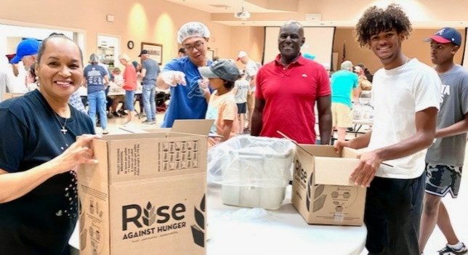

**Outreach**

We remain committed to our community and continue to support various organizations and efforts. We want to make a difference! The financials for outreach are as follows:

|  |  |  |  |  |  |  |  |
| --- | --- | --- | --- | --- | --- | --- | --- |
| ***2023 Outreach Partners*** | ***2023 Budget*** | ***Distribution by Quarter*** | | | | ***Account for Distribution*** | ***YTD  (Actual)*** |
|  |  | **Q1** | **Q2** | **Q3** | **Q4** |  | **2023** |
|  |  | **JAN-MAR** | **APL-JUN** | **JULY-SEPT** | **OCT-DEC** |  | **Amount** |
| **Budget (Original)** | **$17,000.00** |  |  |  |  |  |  |
|  |  |  |  |  |  |  |  |
| Backpacks of Love |  |  | $5,000.00 | $1,975.00 | $1,180.00 | 1-008136 | $8,155.00 |
| Foster Care Support Foundation |  |  |  |  |  |  | $0.00 |
| Georgia Mountain Food Bank (new in 2021)** |  |  | $500.00 |  |  | 1-008102 | $500.00 |
| Meals by Grace (new in 2021)** |  |  | $1,000.00 | $1,500.00 |  | 1-008102 | $2,500.00 |
| North Fulton Community Charities (NFCC)* |  |  | $2,500.00 |  |  | 1-008102 | $2,500.00 |
| Path to Shine |  |  | $500.00 |  |  | 1-008102 | $500.00 |
| Rise Against Hunger |  |  |  | $380.00 |  | 1-008151 | $380.00 |
| Rise Against Hunger |  |  |  | $5,720.00 |  | 1-007010 | $5,720.00 |
| The Drake House |  |  |  |  |  |  | $0.00 |
| The Ronald McDonald House (new in 2021) |  |  | $500.00 |  |  | 1-008102 | $500.00 |
| Southern Environmental Law Center (SELC) | ***(New)*** |  |  |  |  |  | $0.00 |
|  |  |  |  |  |  |  |  |
| **Total Q2, Q3 & Q4** |  | **$0.00** | **$10,000.00** | **$9,575.00** | **$1,180.00** |  | **$20,755.00** |
|  |  |  |  |  |  |  |  |
| Variance |  |  |  |  |  |  | $3,755.00 |

**Backpacks of Love Annual Report**

Backpacks of Love continues to serve the increasing need of food insecure children in North Fulton and South Forsyth counties. In the region served by the Atlanta Food Bank, 1 in 10 children go to bed hungry. Food insecurity is defined by the USDA as a lack of access, at times, to enough food for an active, healthy life for all household members and limited or uncertain availability of nutritionally adequate foods.

In the school year ending May 2023, we served an average of 215 students bi-weekly. Seventeen deliveries were made for a total of 3865 backpacks. In the current school year, we served an average of 220 families from September to December. During the Fall 2023 semester, we consistently hit our maximum delivery capacity of 225 bags per delivery (19 cases of each food item) and still our schools had increased demands we were unable to meet. Currently, Backpacks of Love serves seventeen elementary, middle and high schools in our area.

With their longstanding commitment to outreach, St. Aidan’s is joined by four sister churches in this ministry: Episcopal Church of the Holy Spirit, Johns Creek Baptist Church, Alpharetta Methodist Church, and Zion Missionary Baptist Church. Each congregation provides food and financial support to the ministry. Additionally, food drives from participating schools in the BOL program, outside schools such as Kings Ridge Christian School and other local high school student organizations contributed support. This Fall, IDR Healthcare and DLH Corporation selected Backpacks of Love as a charity to support, donating both food and preparing backpack deliveries for us.

In addition to the food donations, the program currently spends an average of $1000.00 per delivery, and some weeks, depending on food donations, BOL has spent up to $2379.00 to meet delivery needs. Our usual shopping in preparation for each delivery consists of 19 cases of several types of canned food (for example 19 cases soup, 19 cases peanut butter, etc.). Currently, 19 cases of canned chicken costs us $640.00.

Thirty-two dedicated volunteers from St. Aidan’s and other churches in our ministry enable the us to continue its serve to these food insecure children. Within each church supporting the ministry there are volunteers and other community members who make the donations and pick up possible. These dedicated volunteers shop for food, unload it and organize the warehouse, pack and deliver bags and even write thank you notes to our donors. St. Aidan’s plays a vital role in this ministry through its significant volunteer efforts with biweekly food donations, packing and deliveries. As both cost of living and food insecurity continue to increase in our, we depend on continual growth in grocery and financial donations by the congregation each year!

**Rise Against Hunger**

On July 29, 2023, St. Aidan’s participated in a Rise Against Hunger event in Burtenshaw Hall. With over 50 volunteers, we successfully helped pack 15,120 meals which went to benefit those in need around the world. Jesus teaches us that our love for him is all the more present in how we care for those less fortunate than ourselves. He even equates our deeds done for others as if it was being done for him. Well done, St. Aidan’s!

“For I was hungry and you gave me food, I was thirsty and you gave me something to drink, I was a stranger and you welcomed me.” – Matthew 25:35

**Episcopal Relief and Development**

Episcopal Relief & Development works in collaboration with church partners and other local organizations to facilitate healthier, more fulfilling lives in communities that are struggling with hunger, poverty, disaster, and disease. We also work around the world and here in the US responding to and rebuilding after disasters.

Our programs impact the lives of over 3 million people annually. We respect the dignity of all people and view them as our neighbors, working alongside participants regardless of religious affiliation or background.

Our unique expertise, experience and practical knowledge allow us to guide communities to lasting change with a focus on three key priorities:

1. Women

2. Children

3. Climate

Please visit www.episcopalrelief.org to learn more about the important work of ERD and how you can help.

**Prayer Shawl Ministry**

The Prayer Shawl Ministry at St. Aidan’s formed in February of 2023 and meets weekly. We have approximately 10 members, ranging in age from 26-85, who knit and crochet beautiful shawls that are given to people in need of prayers of comfort, healing or blessing.  We have distributed over 25 shawls this year to parishioners, friends/family of parishioners and to local hospice patients.

For more information about join this ministry or to request a shawl, please contact Laura Van Riper at 443-340-5467 or [lauravr1@gmail.com](mailto:lauravr1@gmail.com)

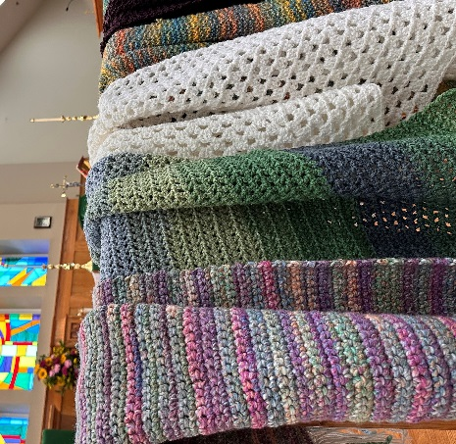

**Blood Drive**

St. Aidan’s has collaborated with LifeSouth Community Blood Center for over 26 years. Blood drives are scheduled twice per year and always on Sundays.

This year, we hosted two blood drives as is our custom. The first was held on February 5th. Participation was good and as a result, **24 Lives were saved**. The second was on June 11th, participation was even better than the first time, and as a result, **33 lives were** saved!

We are hoping to do even better in 2024!

**North Fulton Community Charities**

NFCC’s mission is to build self-sufficiency and prevent homelessness and hunger in our community by providing emergency assistance and enrichment programs. More than 100 local families receive food from NFCC every day. Our Rector, Fr. Reggie, serves on the board of this invaluable agency.

**Operations Christmas Child**

St. Aidans packed 60 shoeboxes that went to needy children across the globe. The mission of Operation Christmas Child is to demonstrate God’s love in a tangible way to children in need around the world. Through this project, Samaritan’s Purse partners with local churches worldwide to share the Good News of Jesus Christ and make disciples of the nations.

**Worship Committee**

**Co-Chairpersons: Father Reggie and Tom Reynolds**

By the Grace of God and the hard work of the clergy, staff, and many volunteers, in-person worship services at St. Aidan’s continued on a regular schedule throughout 2023, supplemented with live-streaming via Facebook, YouTube, and the St. Aidan’s website, which guests often mention as their first introduction to St. Aidan’s.

The Worship Committee meets monthly to review the previous month’s worship activities, plan upcoming worship, and discuss opportunities to enrich the worship experience at St. Aidan’s. Members of the Worship Committee include: Father Reggie, Father Josh, Lay Worship Leader Tom Reynolds, Director of Music Charles Higgs, and representatives from each of the lay ministries that support our worship ministries: Acolytes (Father Josh), Altar Guild (JoAnne Goione), Children’s Chapel (Father Josh), Eucharistic Ministers (Kathy Bump), Flower Guild (Carol Phillips and Jan Quackenbush), Greeters/Daughters of the King (Dr. Vickie Perdue Scott and Corrine Hofstetter), Lectors (Tom Reynolds), Ushers (Dave Hofstetter), and Vergers (Tom Reynolds).

**Vergers**

**Senior Verger: Tom Reynolds**

Vergers assist the clergy in preparing for worship and are responsible for the orderly process of worship services at St. Aidan’s. Vergers are intimately familiar with the rubrics of each service as set forth in the Book of Common Prayer, the role of each person participating in the service, and the tasks of the altar guild, choir, ushers, and others working behind the scenes to insure a meaningful service without any undue distractions.

St. Aidan’s Vergers are Corrine Hofstetter, Jay Reilly, and Tom Reynolds. In January 2023, Foster FitzHugh stepped down from his role as a verger and in October 2023, Heather Okuda also stepped down. Fortunately, in the fourth quarter of 2023, Kathy Bump and Jo Woodard started training to become our next vergers and we are looking forward to working them into the regular service rotation in 2024.

**Lectors**

The members of the Lector Ministry are honored to serve our St. Aidan’s family, proclaiming God’s Word by reading the Lessons during Sunday services, Evening Prayer, and other worship services throughout the year. As Intercessors, we also lead the congregation in the Prayers of the People.

Our goal is to have two Lectors/Intercessors serving during the 8:15 Service and separate Lectors and Intercessors for the 11:00 Service. Lectors usually serve two or three times a

month and we try to coordinate schedules with our other ministries. The talented voices you might hear reading on Sunday morning or at Evening Prayer include: Noah Bowerman, Kathy Bump, Kristin Eastbrooks, Jeff Fisher, Lori Foley, Melanie Hembree, Corrine Hofstetter, Thomas Horner, Kim Hottenstein, Abi Omotoso, Carol Phillips, Jay Reilly, Susan Reilly, Tom Reynolds, Dr. Vickie Perdue Scott, Mac Smith, Gloria Szokoly, Debbie Tomlin, Kay Towner-Stallé, and Noelle Webb.

More Lectors are always welcome, especially for the 8:15 Service, and we would love to have more youth participation! If you can read and have ever read a story to someone else, you are qualified! No formal training is required, just a strong voice and a call to serve. If you are interested in serving as a Lector, please contact Tom Reynolds (tgriv_staidans@outlook.com) or speak with any of our Lectors.

**Evening Prayer**

“Worship isn’t just for Sundays!”

The Episcopal Church has a rich liturgical tradition that can be traced back at least as far as the first Book of Common Prayer, introduced in 1549 by Thomas Cranmer, Archbishop of Canterbury under King Henry VII. At its center is the Holy Eucharist, “the principal act of Christian worship on the Lord’s Day and other major feasts.” Nevertheless, the celebration of Holy Eucharist on Sunday does not stand in isolation. If you read your Prayer Book a little more closely, you will see that, in addition to the Holy Eucharist, “Daily Morning and Evening Prayer … are the regular services appointed for worship in this Church.”   
In 2023, St. Aidan’s began offering regular Evening Prayer services to commemorate Holy Days and other Major Feasts as set forth in the Calendar of the Church Year (found in the Book of Common Prayer at pages 15-33). Our Lay Worship Leader, Tom Reynolds, usually leads these services, which last less than thirty minutes and include Confession,Lessons, Psalms, and Canticles, a brief homily, and prayer. Look for announcements in the Sunday bulletins and the eNews. We would love for you to join us!

**Memorial Services for Our Beloved Animal Companions**

Our animal companions provide a unique connection to creation and expand our sense of God's diverse gifts in creation. The bond between humans and their animal companions can be strong, causing a deep sense of loss, grief, or even guilt over the animal's death, especially when dealing with the loss alone, without the presence of a community of faith, or having the preconception that such an event falls outside the interest of the church. St. Aidan’s provides pastoral care for those who have experienced the loss of a beloved animal companion. We also offer memorial services, using liturgical texts authorized by the Episcopal Church, in

The St. Francis Garden behind Burtenshaw Hall at the head of the nature trail. We held four such services in 2023.

The St. Francis garden became the final resting place for several animals this past year.  St. Aidan’s parishioners buried the ashes of seven dogs. We have plans for at least one more dog and two cat memorial services.

All animal ashes are welcome with partial ashes of a larger animal accepted. The garden is available to St Aidan's parishioners and their family and friends.  Please contact Hazel Gerber ([hazelgerber@earthlink.net](mailto:hazelgerber@earthlink.net)) if you have questions or wish to schedule a memorial service.

**Altar Guild**

The Altar Guild is a ministry and serves under the direction of Father Reggie. The duties of the Altar Guild are to care for the altar, vestments, vessels, and altar linens of the parish. Altar Guild members prepare the sanctuary for services, and then clean up afterwards. They prepare all the things necessary for the celebration of the Eucharist or special services including weddings, baptisms, ordinations, confirmations, memorials, and funerals.

The Altar Guild Team is JoAnne Goione, Corrine Hofstetter, Sharon Johnson, Andrea Manos, Debbie Parkinson, Debbie Tomlin and Dorothy Uidel. We are seeking additional members to join the Altar Guild Team. If you are interested in being part of our team, please contact JoAnne Goione at 770-846-8563 or email [jgsanderson5@gmail.com](mailto:jgsanderson5@gmail.com).

**Flower Guild**

We are one of many important ministries here at St. Aidan’s Episcopal Church who contribute to the beauty and glorification of our Lord within our church walls. We are a self-sustaining ministry, solely dependent on contributions coming from our church members. Currently, we provide for Sunday flowers, and décor (various church seasons), but do not provide flowers for funerals or weddings. We work with a florist in those circumstances. Flower donations for Sundays are $50 and can be ordered (in Thanksgiving for or in Memory of) by filling out our Flower sign up book in the Narthex. Thanks to all of you who support our important ministry!!

***We are always looking to share our knowledge with any of you who might be interested in joining our ministry. Please contact either of the Co-chairs for additional information.***

Current members of the St. Aidan’s Flower Guild are: Jan Quackenbush and Carol Phillips, Co-Chairs ([cbanks2823@gmail.com](mailto:cbanks2823@gmail.com)- Carol, and [jan230@comcast.net](mailto:jan230@comcast.net) -Jan), Melanie Joyce Alexander, Joan Cowart, Cathy Biondi, Edith Jackson, and Sandy Wolsey (currently PRN to help only during church high seasons). Our newest members are Diane Williams and Lori Foley.

We are also appreciative of these folks who lend hands at our busy seasons-Alexis Biondi, Marty McPherson, Anna Melnikoff and Dorothy Uidel.

**Usher Ministry**

The Usher Ministry is one of hospitality, particularly for newcomers, but also for members in need.  Our ushers are always alert for ways they can help while being mindful to promote a sense of reverence, limit disruptions and assist with health emergencies if they arise.

 The ushers follow a comprehensive Ministry Guide developed a number of years ago and revised as necessary since. All are encouraged to do whatever is necessary to ensure each service goes smoothly. We currently have twenty-three ushers, and we are organized into one-person teams for the early service and two person teams for the late service.  We have a number of folks doing double duty, and for that, we are truly thankful.  We love to include the youth on our usher teams as they sincerely enjoy serving.  Two new volunteers have just joined our team and we hope to recruit many more members in the weeks and months ahead. ALL are welcome! For more info contact: Dave Hofstetter 770-664-5494

**Ministry of Music**

Music is an interactive, encompassing and growing ministry at St. Aidan’s. The primary mission of St. Aidan’s Music Ministry, through the support of both staff and volunteers, is to provide the congregation with well-prepared, inclusive and dynamic anthems, hymns, and service music. The Music Ministry also provides opportunities for performance and education, fostering both spiritual growth and participation within the walls of St. Aidan’s and beyond. The foundation of this ministry stems from our Chorister’s Prayer: “Grant that what we sing with our lips, we may believe in our hearts; and what we believe in our hearts, we may show forth in our lives, through Jesus Christ our Lord.” Here are several highlights from the 2023 year:

* Sunday, March 26th at 7pm, St. Aidan’s performed its first Spring Concert for the parish and community, performing John Rutter’s *Requiem*, along with other works by Fauré, Jennings, and Grandjany. Ushers counted 225 in attendance!
* Sunday, April 9th, St. Aidan’s celebrated Easter Day in the majesty and splendor of our beautiful nave. The morning included festive and grand music with a brass quintet, timpani, auxiliary percussion, and organ. Repertoire included works by Delalande, Rutter, Carl, Courtney, Adams and Widor.
* On Thursday, April 20th, Charles performed a solo organ recital at Princeton University Chapel in Princeton, NJ. Repertoire included works by Wagner, Noll, Handel, Gounod, and Bish.
* St. Aidan’s parishioner and professional violinist, Elizabeth Alvarez, regularly provided beautiful music during our worship services. Elizabeth has also assisted with occasional administrative work for our ministry, especially significant preparations for the Christmas Concert.
* Saturday, April 29th and Sunday, April 30th, St. Aidan’s Episcopal Church, in conjunction with Kudzu Acting Company, was proud to feature Gloria Szokoly, professional stage actress, choir member and lector, in Alfred Uhry’s *Driving Miss Daisy*. The exquisite performance was followed by an incredible reception (both days!) in Burtenshaw Hall, coordinated by many volunteers of the parish.
* On Friday, May 13th, Glenda Gray, choir member and professional musical theatre performer, offered a lovely, captivating and musical program in observance of Mother’s Day Weekend, *For the Heart that Holds Me…A Musical Tribute to Mom.* A free-will offering was collected to benefit the Alliance for International Reforestation and St. Aidan’s Friends of Music.
* The St. Aidan’s Music Ministries welcomed the guidance and mentoring of the Music Committee: Foster FitzHugh (Chair and Vestry Member) and Karen Vernon (Vestry Liaison and Choir Member), as well as the Choir Council: Ann Dancy (President), Connie Heefner (Choir Administrator), Karen Vernon, Scott Doig (Librarian) and Lisa Young. The Committee and Council assist with the planning, execution, business practices and overall assessments of the musical happenings at St. Aidan’s.
* Saturday, August 19th, St. Aidan’s held its first-ever Choristers Open House, coordinated and led by Dr. Wanda Yang Temko, Director of Choristers. This exciting two-hour workshop encouraged current/prospective choristers to explore the fascinating world of the children’s choir. Families received this workshop so favorably, and it helped us increase our chorister enrollment from five to ten!
* The Fall 2023/Spring 2024 choral season began in September for both the St. Aidan’s Adult Choirs, directed by Charles Higgs and Dr. Norma Raybon, and St. Aidan’s Choristers, directed by Dr. Wanda Yang Temko.
* Friday, October 6th and Saturday, October 7th, St. Aidan’s had its sixth annual Choir Retreat, held at Alpharetta Presbyterian Church. Led by Nicholas Bowden and Dr. Norma Raybon. The choir worked hard and enthusiastically on upcoming Fall/Christmas Concert Repertoire. Sunday, October 8th the choir offered one of the retreat anthems, *Ev’ry Time I Feel the Spirit* (arr. Moses Hogan) as the offertory, with Jeanné Brown, as featured soloist.
* Saturday, October 21st at 4pm, we offered our first Folk Mass, led by Keith Richards, Folk Ensemble Director. The Mass was very well received, with anticipation for more to come!
* The First Sunday of Advent, December 3rd, St. Aidan’s held a beautiful morning Advent Lessons and Carols service, with Eucharist. Ushers counted over 200 in attendance! With full choir, organ, piano and choristers (directed by Dr. Wanda Yang Temko), the morning consisted of works by Bach, Schweizer, Warlock, Nevue, Handel, Reger, Hayes and Buxtehude. Dr. Norma Raybon, Artist-in-Residence, and pianist Kathy Cahill enhanced our liturgy.
* On December 17th, St. Aidan’s hosted its fifth extraordinary Christmas Concert. The evening featured magnificent works for full choir, orchestra, soloists, organ and congregation. The event was extremely well attended with a count of 340! Featured soloists were Julian Calvin, piano, Julie Koenig, harp, Kelli Young, soprano, Michael Vavases, tenor, and John Arnold, bass. Featured conductors included Mr. Nicholas Bowden, Dr. Norma Raybon, and Dr. Xavier Carteret. The evening concluded with a grand Southwestern styled theme reception in Burtenshaw Hall, coordinated by Suzy Heald and Sandy Thomas.
* Christmas Eve worship included a joyous celebration with a highly successful children’s pageant at the 4pm service, led by Deacon Josh Hilton and Director of Choristers, Dr. Wanda Yang Temko. 8pm Mass included brass quintet, timpani, auxiliary percussion, full choir and organ, performing works by David Willcocks, Joseph Clokey, Jennifer Eklund, Johnnie Carl, Givoanni Gabrielli, Diane Bish, John Rutter, Philip Stopford and Keith Chapman. The 11pm Mass included two trumpets and Atlanta music legend Jeanné Brown as Cantor.

With deep gratitude and unbridled joy to serve the congregation of St. Aidan’s,

Charles Higgs

**Family Ministries**

This was a great year for family ministries! Throughout 2023, we had a successful Vacation Bible school, a Spring and Fall festival, and a Christmas pageant. Our children’s ministry and family fellowship group grew, which has led to more families joining the church. Thanks to the efforts of our children’s leadership team, we now have a total of 17 children in regular attendance for our children’s chapel, and an average of 18 parents and children gathering for a monthly family fellowship group, which is being led by vestry member, Kim Hottenstein. We also launched a children’s Sunday school, led by Laura Van Riper and Pam Steman. Our youth group continues to gather once a month for pizza and Bible study. The youth group is led by me, Abbey Sutherland, and Leslie Clare Hennessey. Leslie Clare and Maureen Richards have faithfully served in children and youth ministries with me since my arrival in 2021. They have truly helped me to lay the foundation for much of our children’s ministry. Leslie Clare has recently had to step down from leadership, as she begins to raise her newborn twin girls. I am excited to see the friendships made through family ministries that have led to the growing family community here at St. Aidan’s! To God be the glory!

In Christ,

Fr. Josh

**Christian Formation**

In the spring of 2023, the Adult Sunday school class completed a yearlong study of *The Study of Anglicanism* by Stephen Sykes, John Booty, and Jonathan Knight. For our yearly Lenten study and soup lunch, we studied the book *Following Jesus* by N.T. Wright. In the fall of 2023, we offered a confirmation class from September through December, resulting in six people being confirmed and three people being received into the Episcopal Church. Additionally, in the Fall, the Adult Sunday school class studied *The Essentials of Christian Theology,* edited by William C. Placher. For the Advent study and soup lunch, we studied *Tokens of Trust* by Rowan Williams. In addition to these formation opportunities, a study of the weekly lectionary readings continues every Tuesday from 9:45 – 11:00 AM, and a study through the Bible continues on Wednesdays at 6:00pm. The Wednesday night Bible study completed a study through the synoptic Gospels (Matthew, Mark, and Luke) through 2023, and we are currently studying the Gospel of John. Jesus calls us to love God with all our heart, soul, strength, and mind. We hope that we have provided plenty of opportunities for you to exercise the latter. Let’s continue to seek after the knowledge of God in the year to come!

**Acolytes**

We are so proud of the acolyte team here at St. Aidan’s! They are a well-polished group who carry themselves reverently as they participate in worship every week. Our team consists of Brendan and Seth Cantelmo, Seth Parson, Paisley-Cate Samples, and our newly titled Master Acolyte, Mac Smith! As a sixteen year old, she has not only achieved Master Acolyte status, but she is also a trained Eucharistic Minister. The level of “Master” was once achieved by years of service. Now any acolyte can achieve rank of “Master” based on merit, knowledge, and theology of worship. We could not be more proud of this exceptional group of teenagers!

**Newcomers**

We had many newcomers visit our parish in 2023. Many have decided to call this place their spiritual home. It is such an honor to be the choice Episcopal parish for those who have decided to visit or join us! This year, I began to call our visitors and offer to get coffee and discuss our communal life here at St. Aidan’s. My hope is for every newcomer to feel welcomed and to know that we are here for them. My hope is to continue to help newcomers to make connections and develop relationships within our parish community. A big thank you to vestry member, Kim Hottenstein, who has led the charge in organizing the family fellowship group, a group for parents and young couples. Kim has been a vital part of connecting new families with existing members of the parish community. As I have said before, the best part of this church is all of you! You are a wonderful group to have as a church family.

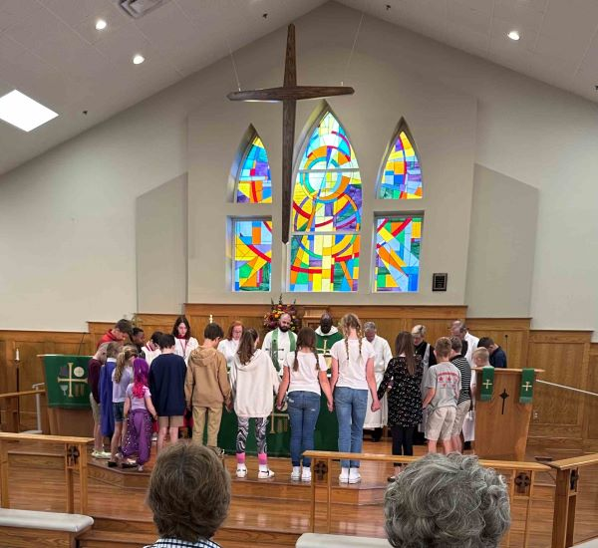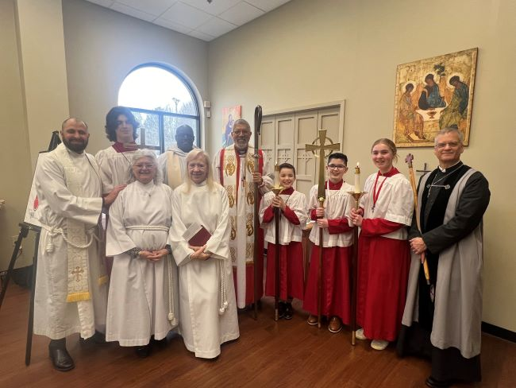

**Building and Grounds**

**Overview:**

Building and Grounds, and thus St. Aidan’s, experienced a somewhat eventful year in 2023. Particularly because of an aging infrastructure, there were maintenance requirements that put the $88,00.00 2023, *Building and Grounds* budget at risk. Notable variances because of unplanned maintenance:

* The elevator required repair due to a failed door controller, total repair cost of $9762.
* A failed (aka “fallen”) sewer line extending 25 feet from the restrooms in the narthex was repaired at a cost of $16,500.00.
* Two, failed “package” HVAC units that serve the Gospel (lefthand) and Epistle (righthand) sides of the sanctuary, are being replaced for $42,700.

Categorically, this report will address primary events as they relate to Building and Grounds (*in alphabetical order*):

1. Elevator
2. Fire protection
3. Housekeeping
4. HVAC
5. Insurance
6. Kitchen
7. Landscaping
8. Pest control
9. Plumbing
10. Roofing
11. Security
12. Utilities

**Elevator:**

In October, Schindler Elevator installed a new IDD door operator in the elevator at a total cost of $9762. This included $2656 for the diagnosis, and $7106 for the installation and testing of the new operator.

By replacing outdated electrical controls and eliminating an assortment of cams, mechanical circuits and resistors that require frequent adjustment, the new controller can dramatically improve existing door performance and reliability.

In February, we discovered that the phone in the elevator was inoperable. Alertline, who provides cellular phone service for the emergency phone in the elevator, sent a replacement modem with an automatic dialing feature that calls Schindler’s call center.

**Fire Protection:**

Fire protection services, provided by ADT (rebranded as EverOn) continued to be a challenge for St. Aidan’s as the service provided by ADT is at best, marginal. Inspections were incomplete, and the required maintenance were challenging to have completed adequately and on time. This resulted in three inspection failures by the Milton Fire Department (MFD) and countless hours of negotiation with ADT to complete all required maintenance such that a passing report by the MFD could be issued. Finally, at a cost of over $5100, we were able to secure a passing report in November.

Our objective in early 2024 is to replace EverOn as a provider. However, identifying an alternative vendor has proven to be challenging in as much as those providers do not offer comprehensive inspections and maintenance (including, the sprinkler system, fire extinguishers, exit signage, etc.) and annual costs are comparable to EverOn. Ideally, we will engage a new supplier in late January so as not to have to renew our contract with EverOn.

**Housekeeping:**

At the first of last year, we elected to change the vendor for housekeeping services from long-time provider Abernathy to Pro-Square, who promised improved service, greater flexibility with respect to managing costs (such as procurement of consumables like tissue and towels) and lower overall contract costs. Unfortunately, the service fell fall short of expectations. As of November 7th of ’23, Abernathy was reinstated as our provider and three day per week service was restored to the pre-school (as well as the for the sanctuary and offices).

**HVAC:**

The church experienced several issues with our many HVAC units. In fact, in total, the church as 18 units, including 5 for the kitchen, 2 for the sanctuary, 1 for the office, 2 for the foyer, 4 for the pre-school and 4 for the trailers. The issues that surfaced in 2023:

* We replaced J.S. Thomas as the HVAC service provider in January with Blue Mountain Mechanical. J.S Thomas consistently disappointed us with both their service and cost.
* Blue Mountain performed their first, semi-annual maintenance at the church in April.
* Blue Mountain repaired a leak in one of the HVAC units in the preschool area, as well as adding a missing “safety switch” that will turn off the unit prior to it resulting in a leak.
* Diagnosed the failed, “epistle side” HVAC unit, indicating a choice between replacing the heat exchanger ($11,500) and replacing the entire unit ($23,500). Given the age of the system (manufactured in 2005), it was deemed that replacing the unit would be a better option.
* Subsequent to the failure noted above, the “gospel side” HVAC failed. To restore heat, we elected to service the unit at a cost of $1170; otherwise, there would have been no heat in the sanctuary. However as noted in the Overview, units on both sides will be replaced in 2024 ($42,700).
* In December, one of the rooftop units serving the pre-school failed as a result of a non-operative “inducer draft motor”. The motor was repaired in January of ’24 at a cost of $1120.
* We noted, at the end of 2023, additional HVAC issues that will have to be addressed in early 2024, in addition to the sanctuary units discussed above, one of four HVAC units, the failed unit being the one in the Scout trailer; it requires replacement at a cost of $4400.

**Insurance:**

In 2023, and although not technically a function of the Junior Wardens or Building & Grounds, Foster Fitzhugh took on the task to identify and negotiate a new comprehensive insurance provider for the church.

* Brotherhood Insurance offered a policy at a lower rate, with lower deductibles vs. the previous insurance company (Church Group of Vermont). The premium of $14,400 netted a first year savings of $2200 in policy savings.
* In July, when “workers compensation” insurance policy was up for renewal, the church switched to Brotherhood for that policy as well. Again, annual savings based upon the 2023 policy cost is $1200.

**Kitchen:**

* Kitchen maintenance was minimal in ’23, we budgeted for a “deep cleaning” of the kitchen and exhaust fan, which was contracted to and completed by Don McPherson. Don not only did a fantastic job, aided by wife, Marty, but performed the task for only $1200, below the cost of an alternate, third party contractor.
* In November, a thermocouple was replaced in one of the ovens for a cost of $250.00.

**Landscaping:**

* Mansell Landscaping continue as provider of landscape services for the church
* In May, we contracted with “Play it Safe” to inspect our playground equipment, motivated by the upcoming “Family Fun Fest”. The inspection included all playground equipment, and several minor deficiencies were noted, including the use of “non-commercial” playground equipment. None pointed to a safety threat, and while changes would be desirable, none have been made in 2023.
* In June, the Jr. Wardens distributed 19 cubic yards of “certified” playground mulch below the wooden playset at the front of Burtenshaw Hall.
* In June as well, Barry Mansell took the lead in connecting the fountain to the irrigation system, finally overcoming the requirement monitor and manually fill the fountain…bravo! The Memorial Garden Fund paid for the moderate cost of $200.
* In September, landscape timbers were installed by Mansell Landscaping at the lower level of Burtenshaw Hall, adjacent to the playground, and which are intended to manage the flooding and resultant mud left on the playground’s artificial turf. Unfortunately, the solution has proven to be only marginally effective.

**Pest Control:**

Active Pest Control provides pest control services to St. Aidan’s. Early in the year, we had issues with Active with respect to their scheduling and timing of service, which, if early in the day was disruptive to the pre-school and its attendees. After discussion, Active now notifies the church of its schedule at least 2 days in advance, and provides afternoon service, after the adjournment of the pre-school. In addition, upon request, they provide incremental service on an “as needed" basis. On two occasions, they were called to remove hornets’ nests in the eaves of the church roof; however, those were performed at incremental cost.

**Plumbing:**

As mentioned in the Overview, St. Aidan’s suffered a failure in the drainage pipe that extends from the restrooms adjacent to the narthex and traveling beneath the narthex and beyond the church offices. The “fallen” pipe occurred under the narthex floor and the repair was made at a cost of $16,500. Offsetting the cost was Barry Mansell’s effort to manage the replacement of the carpet and LVP in the narthex. Barry arranged for LVP to be replaced in Narthex and carpet glued back down in the office hallway with original contractor, at cost of $875.00. Barry personally stripped the old adhesive from the LVP so that the pieces could be reused, as matching product is no longer available in 4” widths.

Late in 2023, Brotherhood Insurance approved a claim for the damage and provided a settlement of over $7000, covering almost half of the original expenditure. Kudos goes to Foster FitzHugh for pursuing this claim with Brotherhood.

**Roofing:**

Again, our aging infrastructure is not helping us manage maintenance and repair costs for any aspect of St. Aidan’s. The roof is no exception. In March, RRG Roofing repaired the roof over the sacristy, by performing three tasks at a cost of $2500.00:

* 1. 2 Vent boots were replaced (one of the boots was incorrect and should not have been used)
  2. Screws that include EPDM (rubber) gaskets were replaced along the trailing edge of the high-pitched portion of the roof that is over the sanctuary.
  3. Additional, silicone sealer was added in selective areas (namely the juncture between the high-pitched portion over the sanctuary, and the shed portion over the church offices) was added.

RRG’s quotation fell between the lowest and the highest quotations ($780-$5900) for the same work. The low quote was not deemed credible by the B&G team.

**Security:**

Paragon Alarm Systems provides both burglar and Fire alarm protection for St. Aidan’s. There were no changes to that service in 2023. The age of our fire alarm and the means by which it is connected to the burglar alarm limits the companies who can provide monitoring to both burglar and fire alarms. Should we replace our fire alarm with a modern system, this would greatly increase our options

**Utilities:**

There were no changes in providers for utilities in 2023. The contract with SCANA Energy, who provides natural gas to the church, expires in August of 2024. Natural gas has been somewhat more volatile in price as of late, and we will want to consider reviewing our options as August approaches for the best terms. Currently, we benefit from an aggressive per therm rate of $.405.

**Right of Way, 2025 Greenway Connector Project:**

The City of Milton is constructing a consistent 10-foot wide sidewalk along the west side of Cogburn Road and the south side of Webb Road, which will be used to connect the area around Cambridge HS to the Big Creek Greenway in Forsyth County, in coordination with other projects expected to be completed in the next few years. Thus, the sidewalk would extend along the front of St. Aidan’s, adjacent to the turn lane, and driveway entrance.

St. Aidan’s has expressed concerns to the city that the right-of-way, acquired through eminent domain, would not only take property from the church, but also infringe upon the monument (entrance) sign and potentially the cottage.

The church was provided with the current plans from which the city is working, and from which the third party appraiser will work in order to develop his appraisal. From the city’s perspective, the stated intent is to provide a fair appraisal, and quoting from a recent email, the city has:

*“A long track record of delivering these capital projects while looking out for the interests of the affected property owners and treating you fairly.  Our appraisers are third party, licensed and approved by the state to do these negotiations.  We will do everything we possibly can to minimize impacts.”*

The plans currently show 5,287 square feet (or .121 ac) of right-of-way to be purchased.  The distance from the existing property line to the proposed property line at its greatest is approximately 20 feet in the area where the right deceleration lane is. Temporary stakes have been placed to mark the area to be purchased by the city.

There are factors that will influence the amount of the appraisal, including whether the cottage is impacted and the potential for the cottage to positively influence the amount of compensation should it be determined to be of historical value (i.e.: eligible to be included on the National Register of Historic Places, or NRHP).

St. Aidan’s was notified in October; therefore, appraisals could begin at any time now. Once appraised, there will be an opportunity to appeal should we deem the appraisal to be insufficient compensation. However, nothing will happen immediately, the choice of a contractor will not be made by the city until the Fall of 2024, and construction of the sidewalk will not begin until 2025.

It should be noted that all is not doom and gloom! The sidewalk project could add to visibility to the church along Cogburn, and the compensation for the land could be used to fund a new monument sign or other improvements that would be of benefit to the appearance of the church.

**Acknowledgement:**

**Bernie Spatz**, our longtime repairperson, continued his valuable role on the B&G team, and we are particularly grateful that he serves as a cost effective alternative to otherwise having to identify and qualify commercial contractors for every task that arises through the year.

**Miscellaneous**

Just as in maintaining a home, the ongoing cost, particularly with an aging infrastructure, of maintaining the church can be expensive and time consuming. In addition to those items mentioned in the report above, a few miscellaneous activities were performed in ’23:

* B&G team, along with others, assisted in removing and replacing several pews and the altar kneelers to make way for the vocalists and musicians that took part in December’s Christmas Concert.
* B&G team set-up and dismantled the four, 12,000 lumen LED outdoor lamps used to backlight the stained glass windows for the Christmas concert and the Christmas vigil services.
* Dumpster has been exploited by people dumping in them. A sign was added stating, “Under Video Surveillance” to hopefully thwart would be violators.
* The side security access panel door to Burtenshaw Hall was repaired.
* Two fans to cool the choir loft were added for the comfort of choir members.
* Annual carpet cleaning was performed by Pro-Squared prior to their contract being cancelled.
* Replaced 24 fluorescent lamps throughout the church.

**A brief Look ahead to 2024**

* Finalize supplier negotiation and contract award for Fire Protection Services.
* Replace both HVAC’s in sanctuary.
* Replace HVAC in Scout trailer (one of four)
* Finalize funding for “Capital Reserve Fund” that will assist in managing payment for unplanned capital expenses, primarily roofing and HVAC.
* Negotiate new natural gas contract (SCANA expires in August of ’24)
* Identifying ways to economize through volunteer initiatives that can reduce the B&G’s budget and positively impact the entire 2023 St. Aidan’s operating budget.
* Replace ceiling tiles and the fluorescent lamp lenses located below the leak in the sacristy (to be done following a repair to be made by RRG Roofing in January, ’24).
* The addition of a pair of handrails on the stairwell in Burtenshaw Hall, designed for use by our preschool attendees.
* Finalize and present a *Capital Assets Funding Requirements* document that will holistically identify Capital fund requirements for all aspects of church maintenance and infrastructure anticipated in the next 3 to 10 years.

**Administration**

**Parish Office**

The end of 2023 brought with it the departure of our former Parish Administrator, Stacey Hatch, who served St. Adian’s for three years. Stacey decided to pursue other career opportunities.

I am serving as your temporary Parish Administrator with joy and with a commitment to our success in serving the St. Aidan’s family and our community at large. So far, I have a few people to thank including Fathers Reggie and Josh, Charles, Tom Reynolds, Barry Mansell, Ann Christensen, Mareed Stollman and Charlene, our bookkeeper.

Anita Hilbun

**Communications**

As we reflect on 2023, it is evident that effective communication has been pivotal in deepening our fellowship and outreach. Our mission, “To know Jesus and make him known,” has guided our efforts, steering us through a year rich in growth and community engagement

2023 was marked by several key events, including our Spring Concert, Spring Festival, Fall Festival, Pints with Priests monthly events, and our Christmas Concert. Our communication strategies played a crucial role in maximizing participation and impact.

Our website saw a 25% increase in visits, following a redesign to improve user experience.

Email newsletters maintained an open rate of 63%, significantly above the industry average.

We also witnessed Social Media Growth: Our Facebook followers increased by 30%, while Instagram engagement grew by 40%. In addition, we received Community Recognition through Kings Ridge Christian School

Thanks to Barry Mansell and George Stalle, who are on the Communications Advisory Committee. They have provided advice on improving information sharing and team cohesion.

For 2024, we aim to launch a podcast series, develop community engagement, and enhance social media content. We will focus on fostering partnerships with community organizations to enhance our service reach.

This year’s achievements reflect our community’s vibrant spirit and commitment to sharing God’s love. We thank everyone for their continuous support and welcome suggestions for further improvement.

**Finance Committee**

Members of the committee in 2023 were Fr. Reggie, Bob French Chairman, Mareed Stollman Treasurer, Charlene Smith, Accountant, George Stalle as Vestry Liaison, and Ann Christensen, Lori Foley & Sayo Omotoso, Members at Large.

The committee meets the second Monday of each month at 7pm via Zoom. The responsibilities of the committee are:

1. Monitor monthly and YTD financial performance of the church and pre-School.

2. Produce Monthly Minutes of each meeting.

3. Investigate any budget variances and report.

4. Provide Financial Recommendations on various topics for vestry consideration.

5. Annual Audit Completion

6. Annual Budget Preparation and presentation to Vestry.

Minutes of the meeting are available from the vestry and all items above were completed in a timely fashion in 2023. Anyone interested in serving on this committee please contact bobfrench@dynamixgroup.com.

**Endowment Program**

The St. Aidan’s Endowment Fund was established in 2009 to support future ministries of the church through planned giving. Parishioners can make provisions for St. Aidan’s through their wills, trusts, stocks, real estate, life insurance, etc. The St. Aidan’s Endowment Board set up a structure for parish endowment funds with clear purposes, investment policies and spending rules to assure potential donors that the money they leave in their wills or give in a life-income gift will be managed well and used for the purposes they intended.  In 2011, the Endowment Fund was named The Crann Beatha (Tree of Life) Fellowship. The ‘Tree of Life’ symbolizes eternal life, the ability to support the life of another or others. The Endowment Board is gearing up to provide information and resources to parishioners about preparing for their future and leaving their legacy though estate planning and lifelong gifts.

**Stewardship**

The Stewardship Theme for 2024 is “Show Thanks to the Lord for all his gifts around us.”

We are feeling a growing joy and vitality in our parish! Have you noticed more children at the altar for the Lord’s Prayer, the number of people participating in Confirmation Class, Sunday

School offerings for children and adults, and more fellowship and service opportunities? This growth represents many hands at work, as well as the funding that supports that growth.

It is the season to be both cheerful and generous givers. By following our heart and giving of our treasures, we ensure that we continue to grow our current ministries, and those *new ministries God has put upon our hearts*. Some examples of what the current ministries we support in our giving include are:

**Outreach**: Backpacks of Love, North Fulton Community Charities, Prayer Shawls,

**Children and Family Ministries**: Supplies for Children’s Chapel and Sunday School, VBS, Annual Fall Festival w/ trunk or treat

**Worship**: Flower Guild, Ushers, Altar Guild, Acolytes, Lectors, Eucharistic ministers and Vergers

**Music**: Choir, Choristers, concerts, instrumentalists…

**Facilities**: Volunteer days, garden maintenance and watering, watering, watering, setup & cleanup for events, Jr. Wardens to oversee them all!

Throughout the history of St. Aidan’s, we have been faithful stewards of the work of the church, our rectors and staff that do the daily work, and the facilities that house our community.

Our Campaign culminated on November 5, 2023, with Consecration Sunday and a Celebration Luncheon.

Pledges committed thus far this year total $505,481.08 compared to $474,863.96 in the prior year.

Stewardship Team Members who contributed their time and talents are Phyllis Arshun, JoAnne Goione, Mary Kathryn Nix, Corrine Hofstetter and Wade Hembree.

**Parish Life**

**Fellowship and Events**

2023 proved to be a year of numerous events!

* + In January, we had an Epiphany service, Parish meeting, and a commission for Tom Reynolds as a Worship Leader.
  + February provided us a chance to join together in a Pancake Supper to kick off Lent.
  + In March, we had a beautiful Requiem Service.
  + April found our parishioners gathered to stuff Easter Eggs for the Easter Egg Hunt on Sunday.
  + In May, we had a concert to honor Mother's Day, featuring the lovely and talented, Glenda Gray and our friend Charles Higgs.
  + June brought the ordination of Josh Hilton with a large number of St. Aidan's folks in attendance.
  + Pints with Priests began in July. These are monthly events where we enjoy libations with our Priests along with good company, and great conversation.
  + Our Vestry Retreat was in August. This event brought our Vestry together for a rewarding time of planning and connection.
  + October we had a Folk Mass and a Fall Festival with good attendance.
  + In addition, December we had Lessons and Carols, an outstanding Christmas Concert and Reception.

Good times for Fellowship!

Corrine Hofstetter

**Breakfast Ministry**

Our Breakfast Ministry continued to serve wonderful breakfasts throughout 2023, with VERY FEW volunteers. Despite that, the food and fellowship were superior.

WE NEED YOU! Please join the Breakfast Ministry team! Please contact Don [McPherson—dmac0357@yahoo.com](mailto:McPherson—dmac0357@yahoo.com) and join a team. Many hands make light work…

**Retired Men**

This fellowship group meets every Thursday, 9:30-11, in Burtenshaw Hall to meet and discuss current events, and keep the fellowship going. The group has been meeting for 10 years!

**Women’s Fellowship/ Center Stage Book Club**

This fellowship name has been shortened to the Book Club! Attendance averages around 10-12 ladies for each session and the group meets on the second Wednesday of the month. The club considers new titles and new authors. Many times, a member provides a summary and recommendation for us to review, and we select a book to read based on that recommendation. The group enjoys Classics and Best Sellers! At the meeting the following month, the chosen book is reviewed and rated on a scale of 1-10. Then the group usually goes to lunch at a nearby restaurant.

**Boy Scout Troop 1459**

Troop membership is currently 47 scouts in seven patrols, with 15 active adult leaders and 6 committee members. Four scouts earned their Eagle Rank this year through service projects benefitting local parks, Cambridge High School and St. Aidan’s preschool. There are four additional scouts with Eagle projects in the planning stage.

Troop 1459 conducted an outdoor event each month, including two backpacking trips, a rock-climbing trip, a canoe trip on Okeefenokee, caving, and whitewater rafting. Younger scouts focused on fun and advancement during summer camp while older scouts challenged themselves with a 7-day Scuba diving adventure in the Florida Keys.

Troop service activities included collecting over 1200 canned food items for North Fulton Community Charities, service projects for the church, setting up the 9/11 Memorial at Cambridge High School, and serving as Color Guard for the presentation of our nation’s flag at Milton Veteran’s appreciation breakfast on Memorial Day.

A leadership transition will occur at the end of 2023, with a new Scoutmaster and Committee Chair stepping up to carry on the mission of the Boy Scouts of America. As is common in our troop, former leadership will continue on in other supporting roles.

The troop remains dedicated to maintaining a “screen free” environment to hone our youth’s social and interpersonal skills, as well as recognizing and appreciating the gift and beauty of the outdoors. As BSA founder Baden Powell has said, “We are a school of the woods”.

We sincerely appreciate the continued support of the church for the troop and scouting.

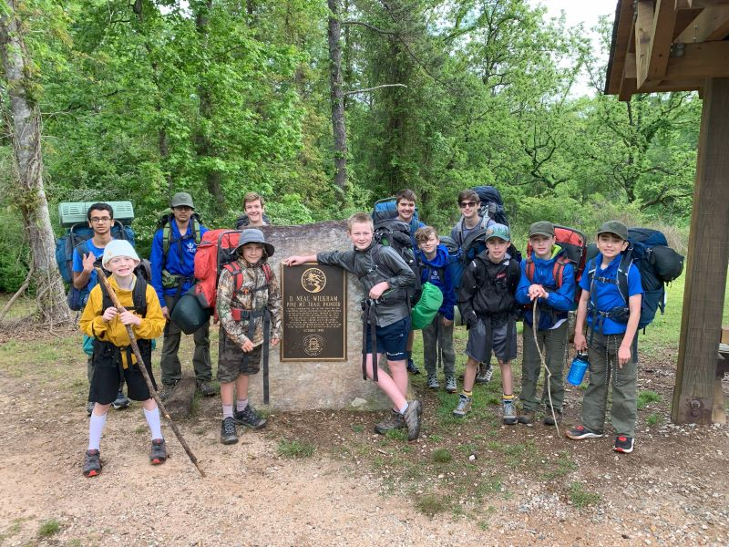

**St. Aidan’s Preschool Academy**

For the first half of 2023, the preschool had eight children enrolled. We held many of our annual events, including the spring concert, teacher appreciation, pastries with parents, a field trip to a nature preserve and graduation for our PreK & TK children. These events help to foster a close relationship with our preschool families.

During the summer, we implemented a summer camp program in June & July. Parents could sign up to bring their children from 9:00-12:00 for 2 weeks during the month of June and 2 weeks during the month of July. There are not many summer camp programs available for the preschool age so we are happy to be able to offer this program for parents. Each day the children would participate in outside activities, science experiments, art & music.

In August of 2023, the school year started with 94 children enrolled and we are holding steady at 95. Our MMO & 2 year old classes are full, while we still have space in our 3-year-old classes and PreK. Over the fall semester, we held many school events. The Milton fire department visited us with their fire truck. Our Halloween festivities included Trunk or Treat and a staff costume contest. We took a field trip to Uncle Shuck’s Corn Maze & Pumpkin Patch, which included a hayride, corn maze & more! Over 100 people attended our annual Thanksgiving Feast! In December, we held our third annual Christmas Fair! The children had so much fun playing games and visiting with Santa & Mrs. Claus! The families had a wonderful time!

Our staff has done a wonderful job of continuing to implement our program. We are providing a Christian based curriculum that includes reading readiness, math skills, creative art and social skills. The children also participate in chapel, Spanish, music & movement, and Handwriting without Tears for our Pre-K children. We have continued our weekly Bible lessons with Father Josh. Our library area is a place for the children to read books of their own choosing or have story time with their teachers. The staff has also completed their yearly training with First Aid/CPR, Safeguarding God’s Children and Health & Safety training.

The preschool looks forward to continuing our well-rounded curriculum. We are eager to grow our presence by marketing the school to the Milton communities!

Blessings,

Julie Aleksandrowicz

Director, St. Aidan’s Preschool Academy

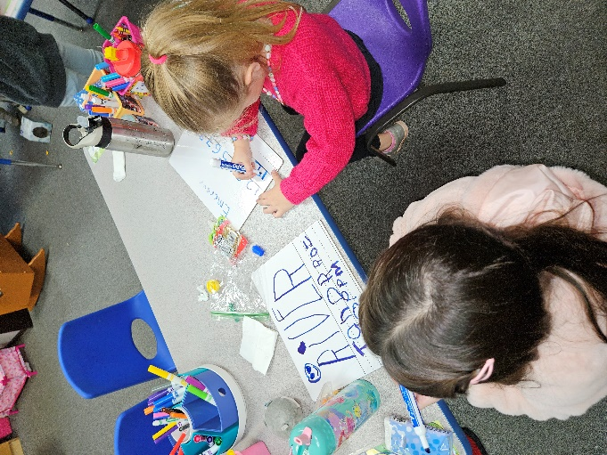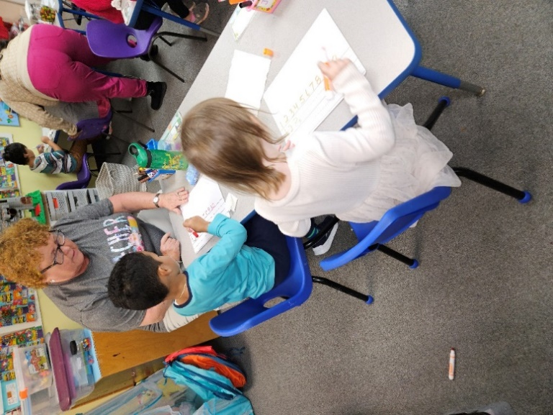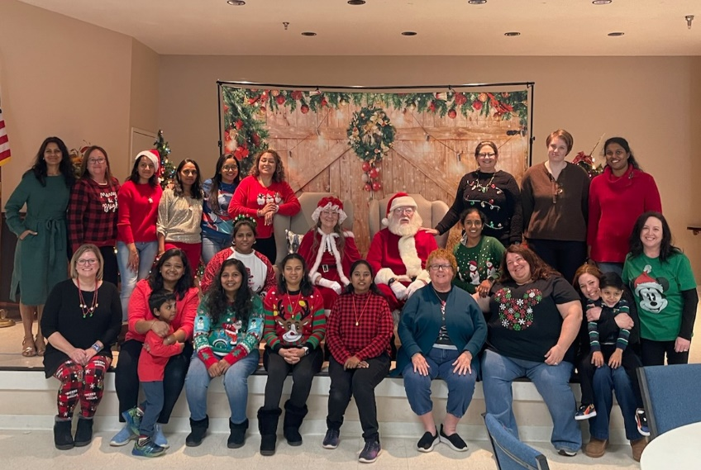

# Annual Report of St. Aidan’s Treasurer as of 12/31/2023

St. Aidan’s had another busy year, financially speaking.

We continued to focus on strengthening our Accounts Payable process and enhancing our Internal Controls throughout the year. In April, we transitioned our Accounting Services to our current Bookkeeper – Charlene Smith. A two-year audit of the Church and Preschool financials was completed, bringing us current.

Major accomplishments for 2023 included:

1. 2023 Budgets for the Church and the Pre-School (fall term) were completed in February 2023 and August 2023 respectively.
2. We transitioned our Accounting Services functions from an external firm (CRI/Mauldin & Jenkins) to Staff (Charlene Smith – our Bookkeeper & HR Administrator). This allows us to have greater integration between Bookkeeping and Accounting, and saves approximately $8,000 per year with Accounting Services.
3. James Jordan & Assoc. was hired as our Audit Partner in June of 2023. The firm conducted their two-year Audit of the Church and Pre-School Financials for 2021 and 2022 over the summer months; audit findings and summary recommendations were provided to the Vestry in October of 2023. St. Aidans received a favorable opinion from the Auditors, and we implemented process and system improvements to follow the guidelines and recommendations given to us by our Audit Partner.
4. Parishioners continued to access the Realm Contribution Management System, to make a pledge online, inquire on contributions credited to their account, and make contributions and donations directly into Realm.
5. The Annual Budget process for St. Aidan’s was streamlined and accelerated for the 2024 budget, enabling a first view to be completed and presented to the Vestry in November of 2023.

The year 2023 ended with a small loss of $16,943 – just 2% of the $831,984 annual budget.

Looking forward to a successful 2024!

*Mareed Meek Stollman*

*St. Aidan’s Treasurer*